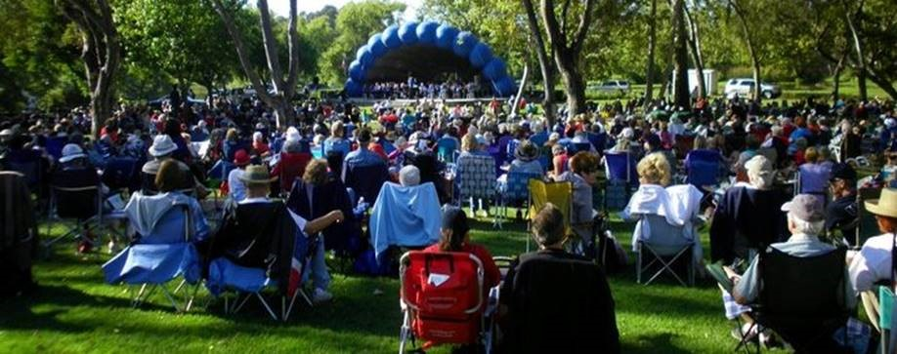
Huntington Beach Concert Band Seeks Conductor
The Huntington Beach Concert Band has provided high-quality music performances in Orange County for the past 50 years. The famed Summer Series in Huntington Beach Central Park attracts up to 2,000 fans each Sunday in the summer. The band makes frequent appearances at the Nixon Presidential Library and presents concerts in Huntington Beach and neighboring cities. The 75-member band (average tenure 17 years) has been directed for the past 46 years by Tom Ridley, who is retiring in 2023. The band, a member of the Association of Concert Bands, holds a music library of more than 1,400 scores. Rehearsals are held at Marina High School on Tuesdays, 7:00 to 9:00 pm.
The Conductor is responsible for the artistic direction and performance quality of the band. The Conductor must have a broad knowledge of concert band literature that challenges players and appeals to a diverse audience. The Conductor serves as the public “face” of the band through appearances, participating in fundraising efforts, and generally representing the band in the community.
The Conductor is supported by an experienced and active Board of Directors and 75 dedicated and skilled amateur musicians. The 501(c)3 organization is in sound financial condition based on member dues, audience contributions, and gifts from corporate and private donors. The part-time position of Conductor is rewarded with a stipend commensurate with experience. The band will soon conduct a search for a Business Manager to relieve the Conductor of nonmusical responsibilities.
For more information on the Huntington Beach Concert Band, see hbconcertband.org
Interested candidates should submit a letter of application by June 1 to Huntington Beach Concert Band, Box 6952, Huntington Beach, CA 92615-6952 or via email to tom.ridley@verizon.net
The letter of application should include the following: (a) a resume of music education and professional music experience that demonstrates proven rehearsal and conducting experience, (b) playlists of three recent concerts that you programmed and conducted, (c) links to video recordings of your conducting (if available), and (d) at least three references (with contact information), such as mentors, peer musicians, or players under your direction.
The Search Committee will respond to all applications. Finalists will be invited to interview in person in July and to conduct a rehearsal session of music selected by the Search Committee in August 2023.

